

**PROTOCOL**to exercise

***Parasitic capacity***

|  |  |  |
| --- | --- | --- |
| Class | Secretary | Signature |
| **4BHELS** | **HOFSTÄTTER A.** |  |
| Exercise- / Delivery date | Employee | Signature |
| 8th October 2014  15th October 2014 |  |  |
| Teacher | Employee | Signature |
| GRASINGER |  |  |
| Grade | **Employee** | Signature |
|  |  |  |
| ***Parasitic capacity*** | | |
| **Used Devices**   |  |  |  |  |  | | --- | --- | --- | --- | --- | | Nr. | Device | Manufacturer | Type |  | | 1. | **Oscilloscope** | **-** |  |  | | 2. | **Function generator** | **-** |  |  | | | |

# General Information

In electrical circuits, parasitic capacitance, stray capacitance or, when relevant, self-capacitance, is an unavoidable and usually unwanted capacitance that exists between the parts of an electronic component or circuit simply because of their proximity to each other. All actual circuit elements such as inductors, diodes, and transistors have internal capacitance, which can cause their behavior to depart from that of 'ideal' circuit elements. Additionally, there is always non-zero capacitance between any two conductors; this can be significant at higher frequencies with closely spaced conductors, such as wires or printed circuit board traces.

# Task

The task was to measure the parasitic capacity of a coil.

* With the use of a rectangle generator and an oscilloscope the intrinsic resonance of the coil was measured.
* The parasitic capacitance was calculated (with consideration of the probe values)

# Measurement construction

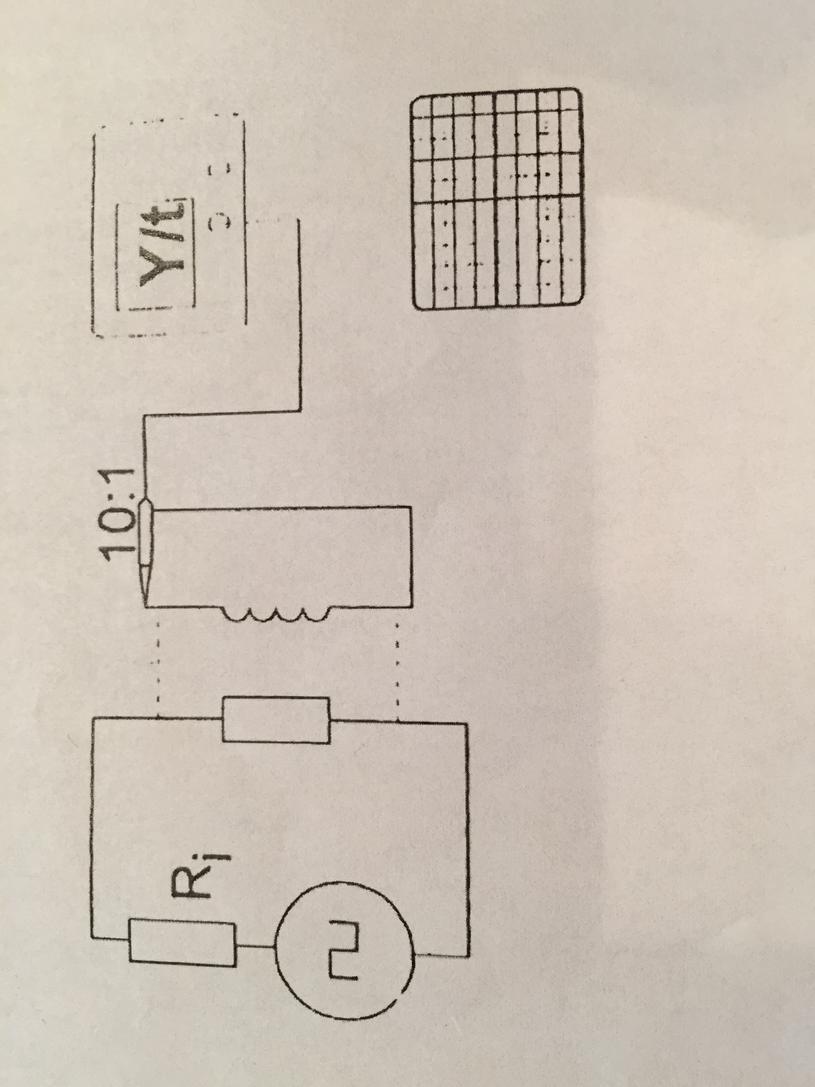At the end of the function generator a 75 Ohm termination resistor was connected. This generator had a 10 kHz rectangular signal as an output.

The coil was connected via probes (10:1) to the oscilloscope. If the coil gets holded close to the termination resistor a signal gets inducted into the coil.

# Measurement results

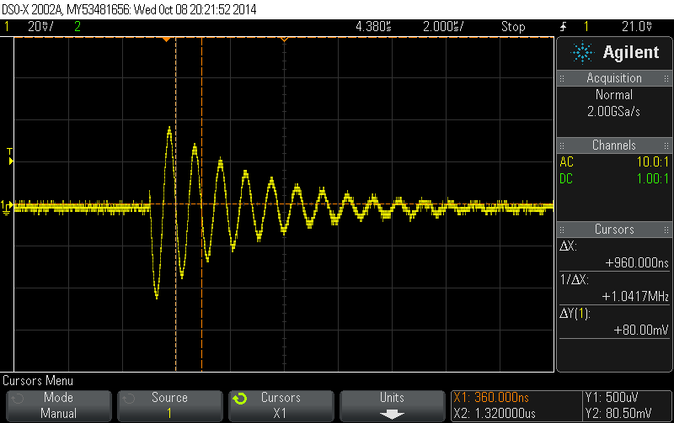As mentioned above in this measurement the coil gets hold near to the termination resistor.

So the following picture shows the inducted signal which gets into the coil.

With cursors the period length (T) was measured and with the calculation of the resonance frequency was calculated.

T= 950 ns -> 1/T = 1,0526 MHz

So the resonance frequency was about 1 MHz.

t/div: 2µs V/div: 20mV

# Calculation of the parasitic capacity

Know values:

* Inductance of the coil: 1mH (L)
* Resonance frequency of the resonating circuit: 1,0526 MHz (fr)

This is the capacity from the coil plus the capacity of the probe.

After this calculation the parasitic capacity of the coil is 7,8619 pF.